**Assignment 3**

**Serjeel Ranjan**

**19BCS009**

1.Create a Bucket in IBM object storage.

Search for object storage on IBM dashboard and click in object storage

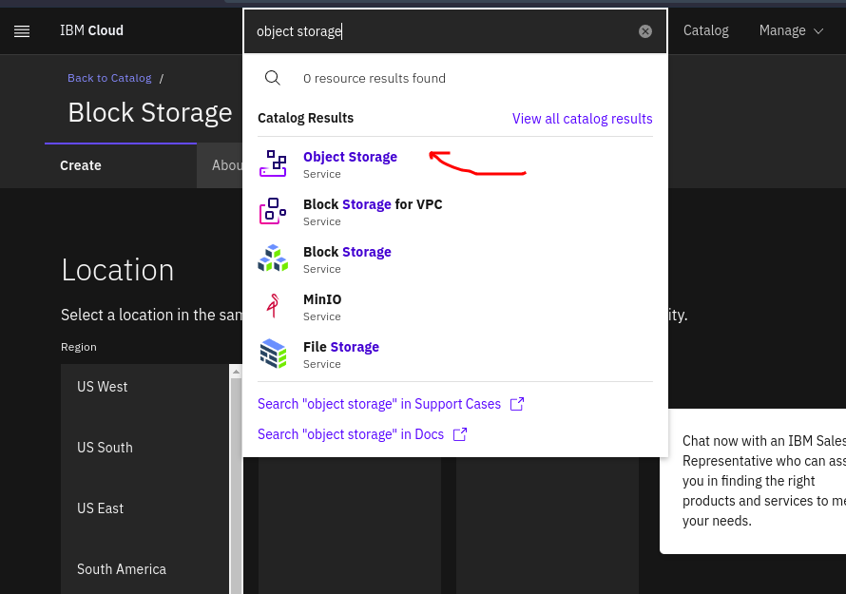

Give appropriate name to your block storage and click on Create

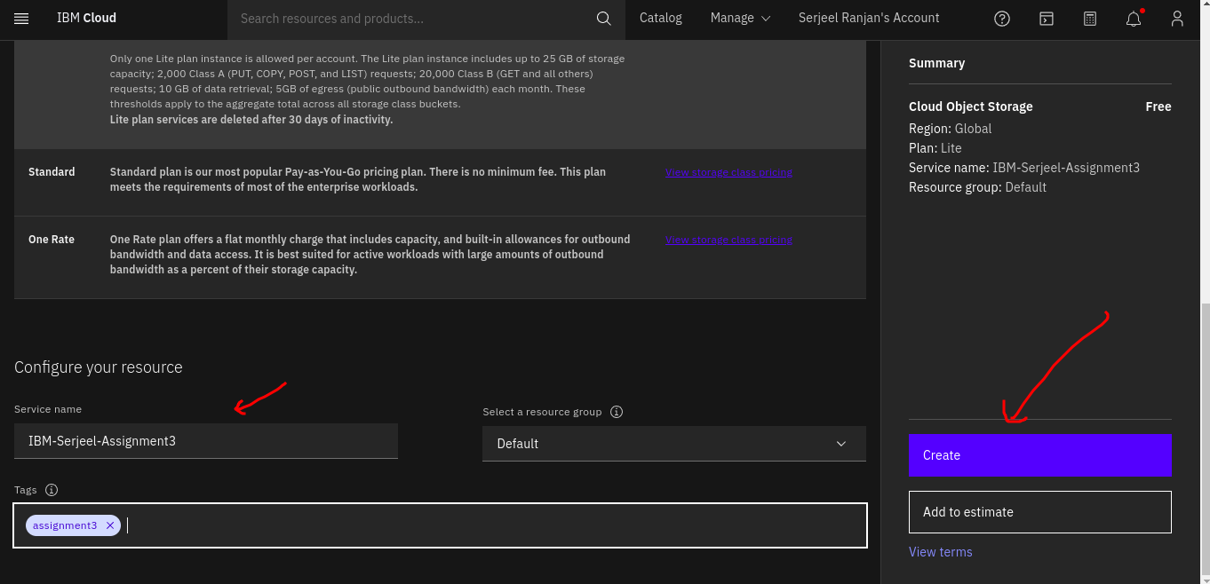

Click on bucket from left bar and click Create Bucket

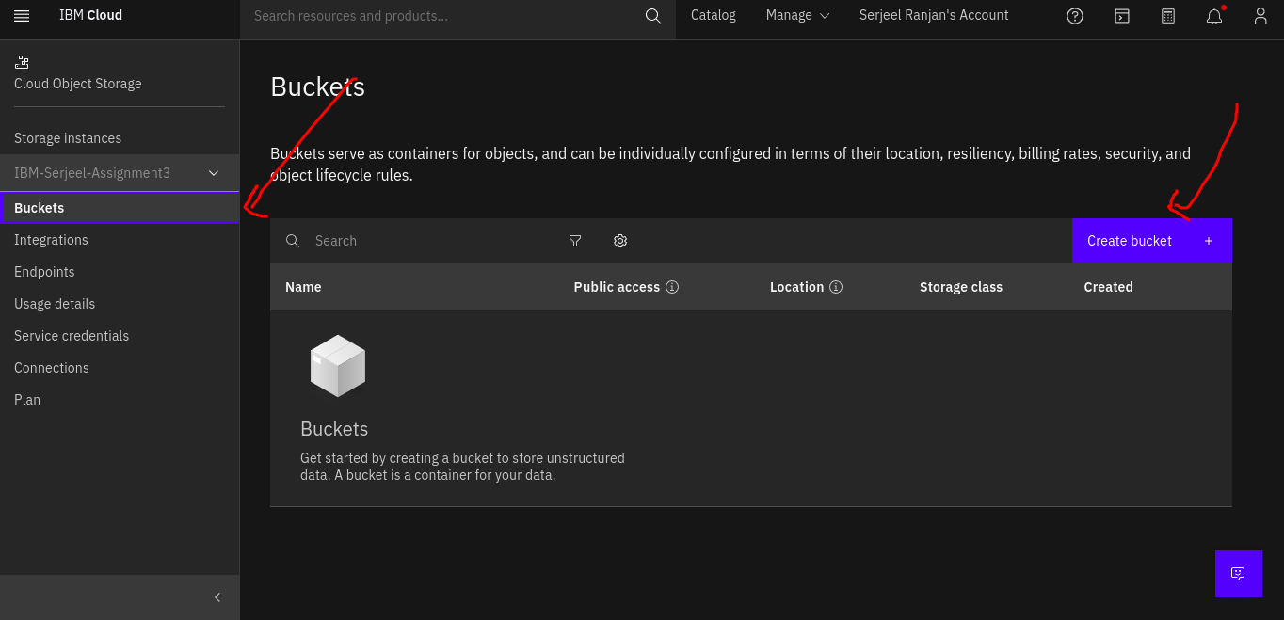

Click on Custom Bucket

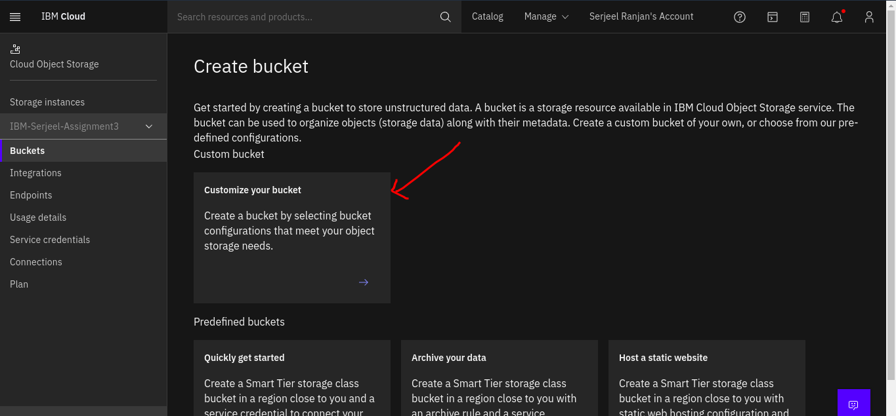

Give unique name to your bucket and click on create

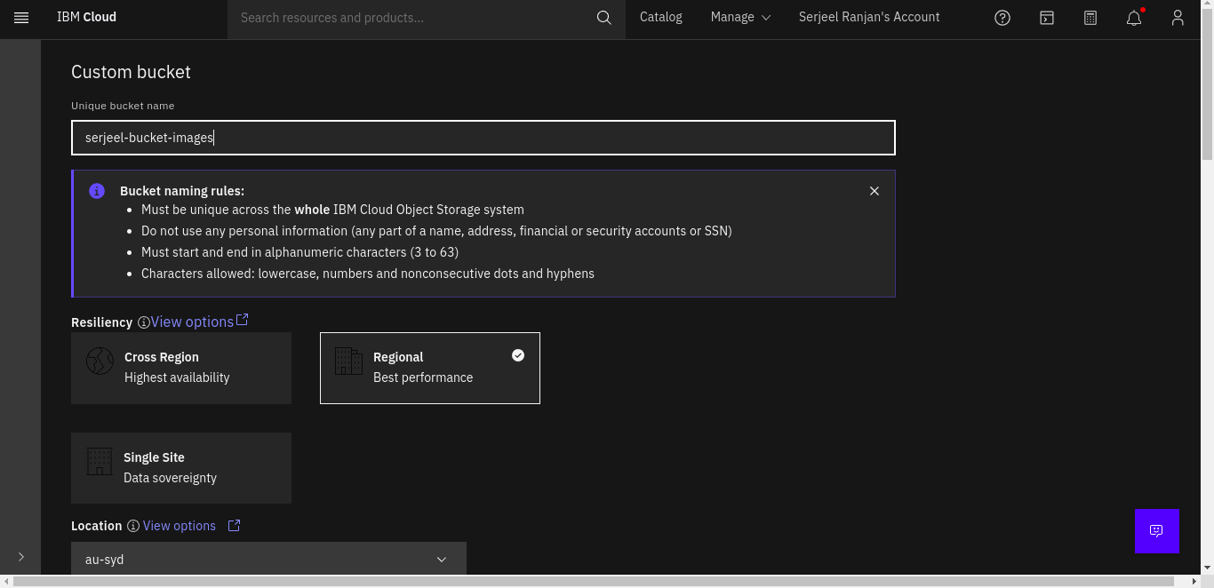

Bucket created successfully

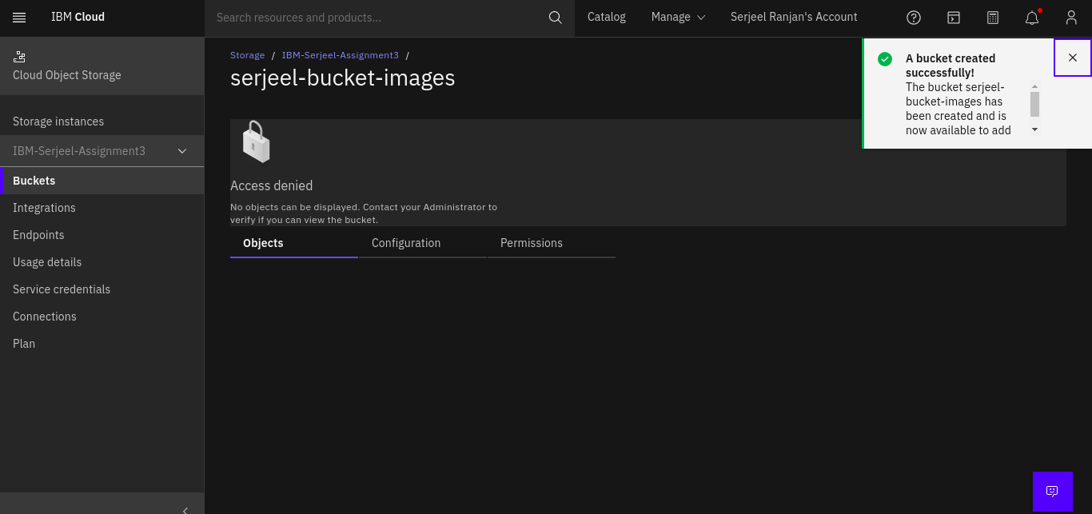

Click on Service Credentials then create new credentials

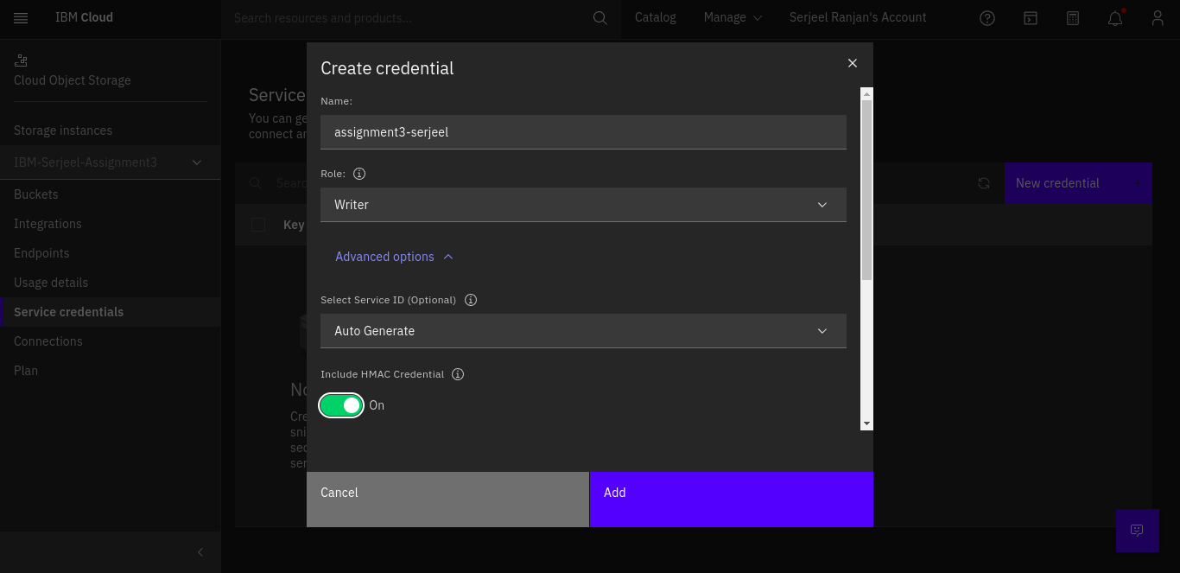

Bucket was successfully created

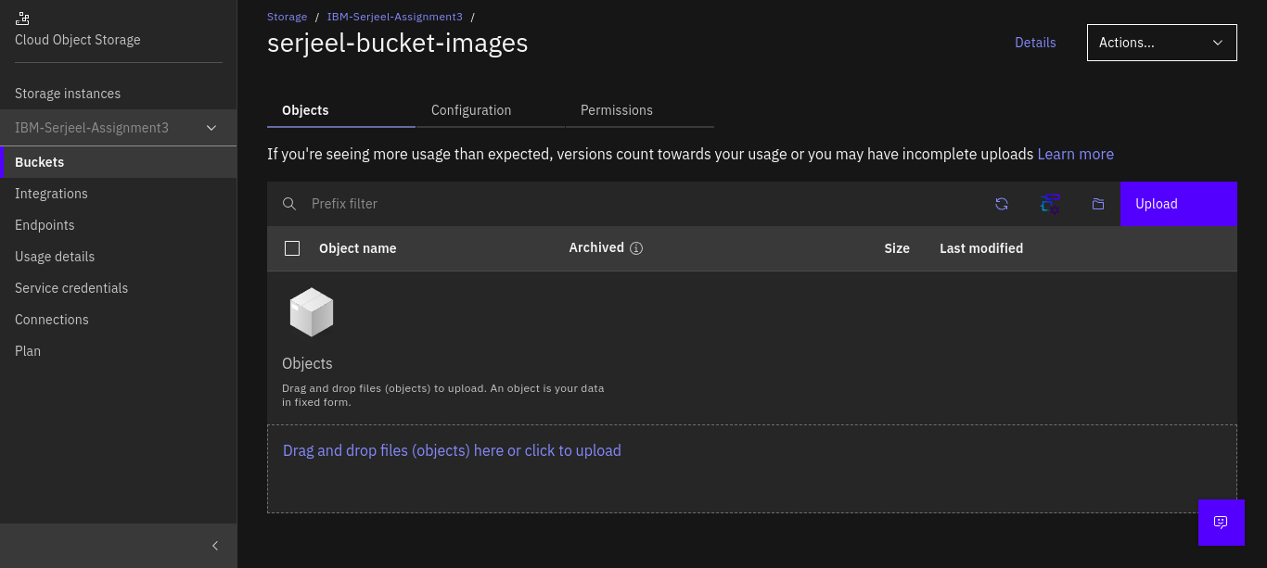

2.Upload an 5 images to ibm object storage and make it public. write html code to displaying all the 5 images.

Click on upload in bucket

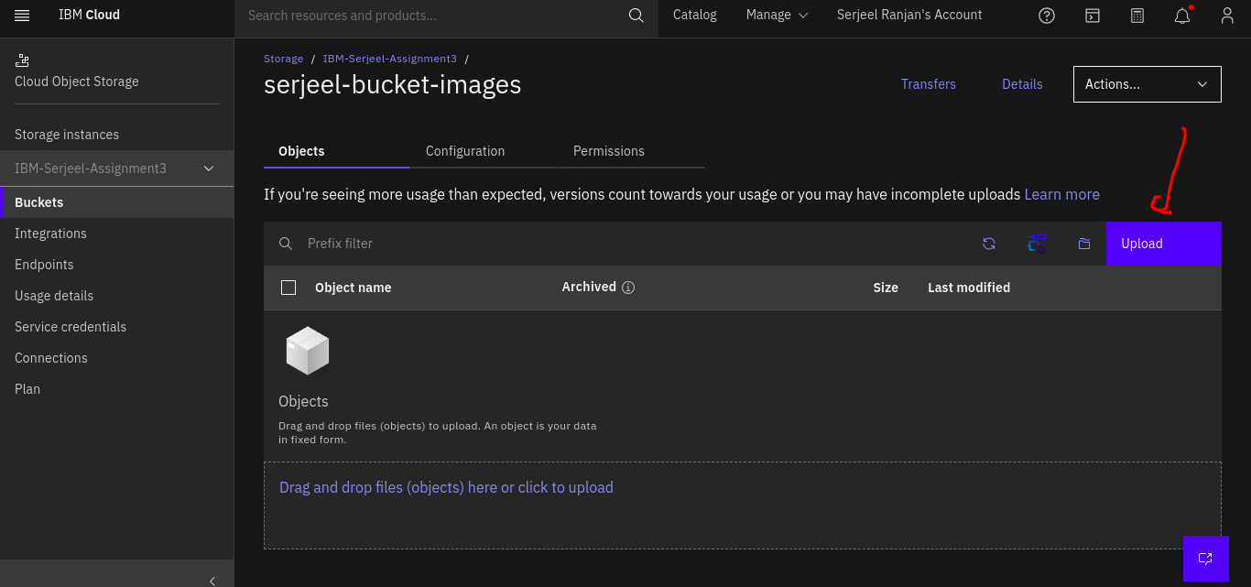

Click on drag and drop files

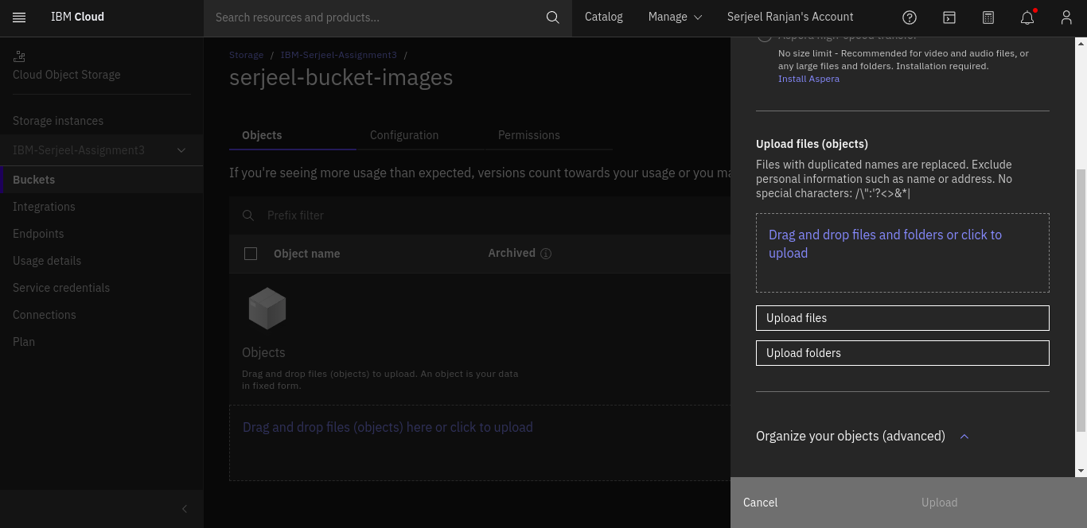

Select images

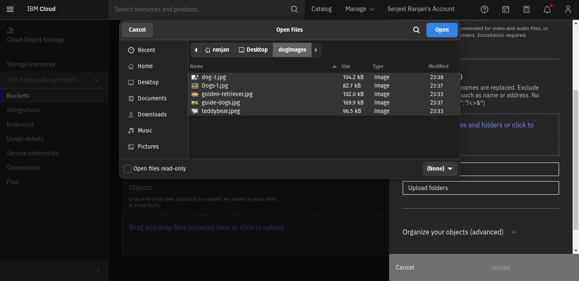

Click on upload

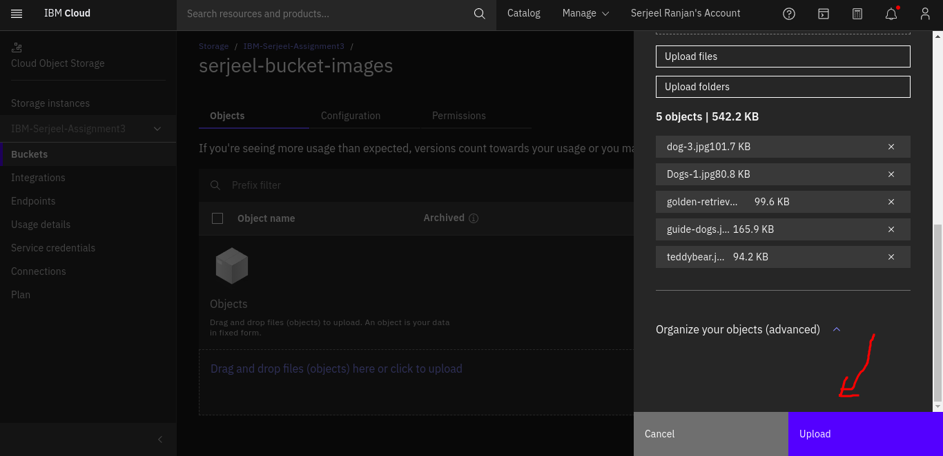

Images uploaded

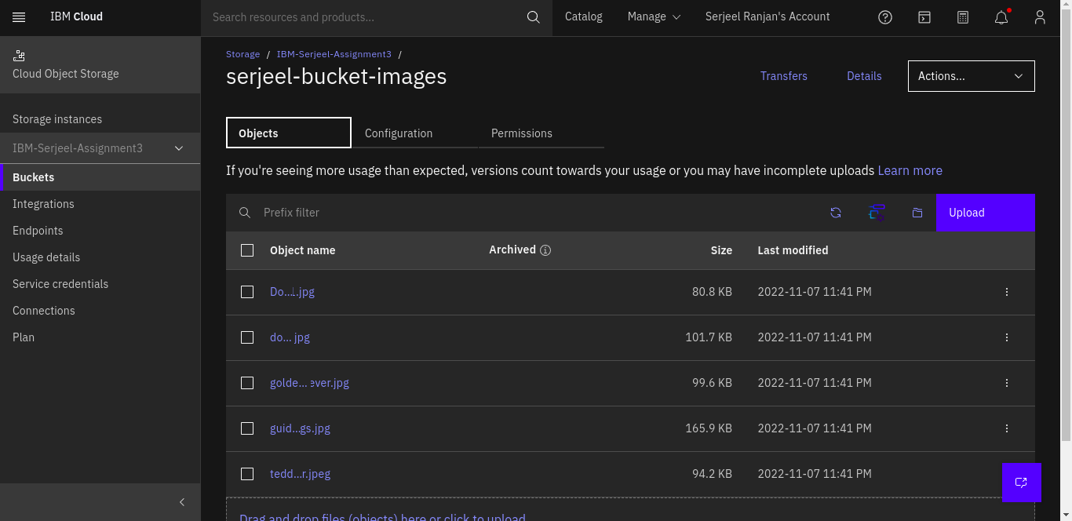

Change permissions under public access

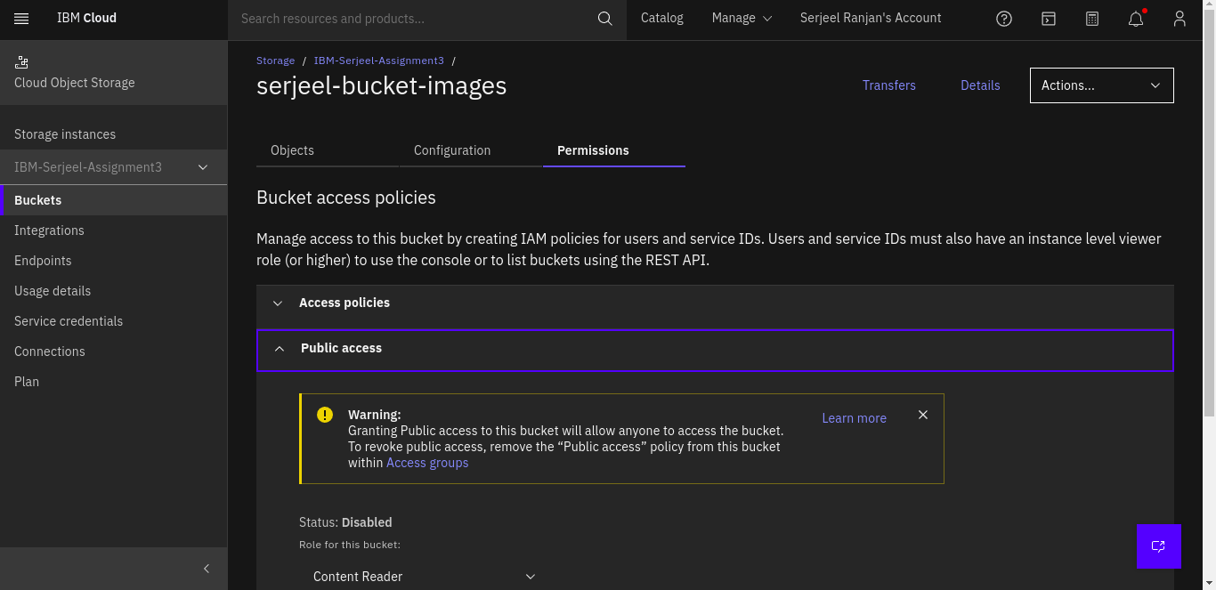

Enable public access

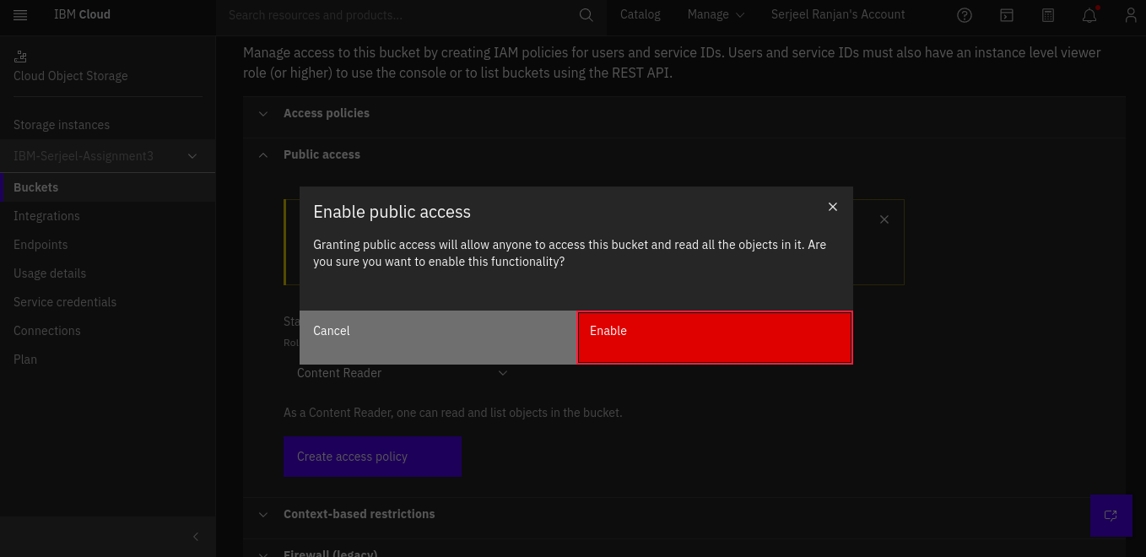

Displaying all the image in html

<!DOCTYPE html>

<html lang="en">

<head>

<title>IBM Assignment</title>

</head>

<body>

<img

src="https://serjeel-bucket-images.s3.au-syd.cloud-object-storage.appdomain.cloud/Dogs-1.jpg"

alt="img1"

width="auto"

height="400"

/>

<img

src="https://serjeel-bucket-images.s3.au-syd.cloud-object-storage.appdomain.cloud/dog-3.jpg"

alt="img2"

width="auto"

height="400"

/>

<img

src="https://serjeel-bucket-images.s3.au-syd.cloud-object-storage.appdomain.cloud/golden-retriever.jpg"

alt="img3"

width="auto"

height="400"

/>

<img

src="https://serjeel-bucket-images.s3.au-syd.cloud-object-storage.appdomain.cloud/guide-dogs.jpg"

alt="img4"

width="auto"

height="400"

/>

<img

src="https://serjeel-bucket-images.s3.au-syd.cloud-object-storage.appdomain.cloud/teddybear.jpeg"

alt="img5"

width="auto"

height="400"

/>

</body>

</html>

3.Upload a css page to the object storage and use the same page in your HTML code.

Upload the css file to cloud storage

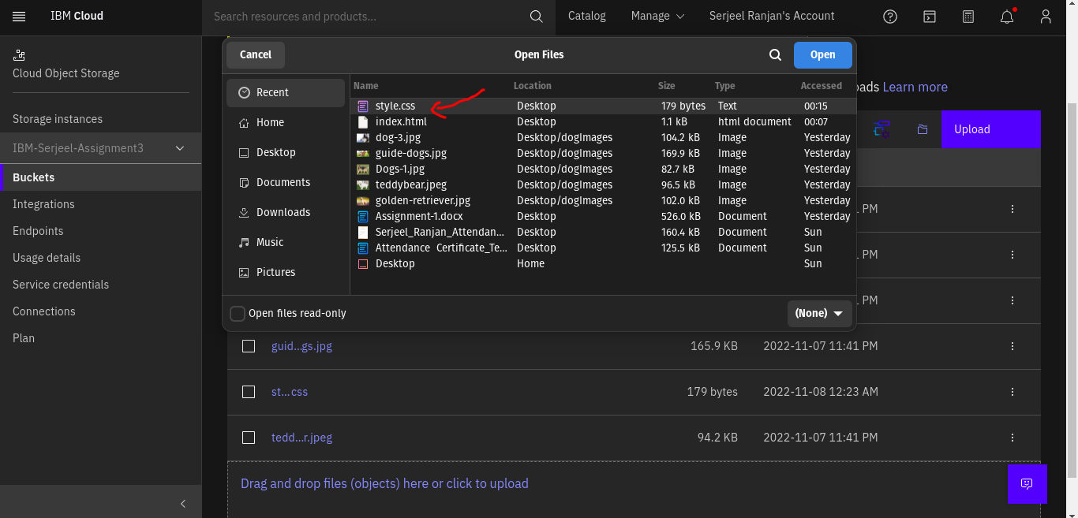

Copy the public url for css file and use in html code

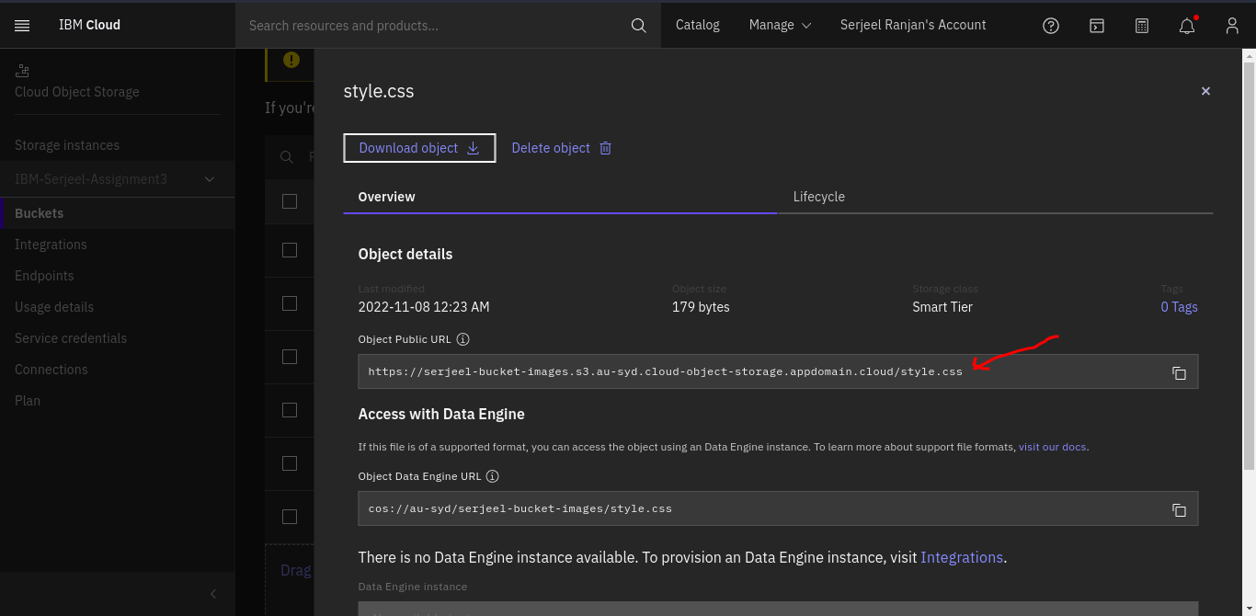

<!DOCTYPE html>

<html lang="en">

<head>

<title>IBM Assignment 3</title>

<link

rel="stylesheet"

type="text/css"

href="https://serjeel-bucket-images.s3.au-syd.cloud-object-storage.appdomain.cloud/style.css"

/>

</head>

<body>

<img

src="https://serjeel-bucket-images.s3.au-syd.cloud-object-storage.appdomain.cloud/Dogs-1.jpg"

alt="img1"

width="auto"

height="400"

/>

<img

src="https://serjeel-bucket-images.s3.au-syd.cloud-object-storage.appdomain.cloud/dog-3.jpg"

alt="img2"

width="auto"

height="400"

/>

<img

src="https://serjeel-bucket-images.s3.au-syd.cloud-object-storage.appdomain.cloud/golden-retriever.jpg"

alt="img3"

width="auto"

height="400"

/>

<img

src="https://serjeel-bucket-images.s3.au-syd.cloud-object-storage.appdomain.cloud/guide-dogs.jpg"

alt="img4"

width="auto"

height="400"

/>

<img

src="https://serjeel-bucket-images.s3.au-syd.cloud-object-storage.appdomain.cloud/teddybear.jpeg"

alt="img5"

width="auto"

height="400"

/>

</body>

</html>

OUTPUT

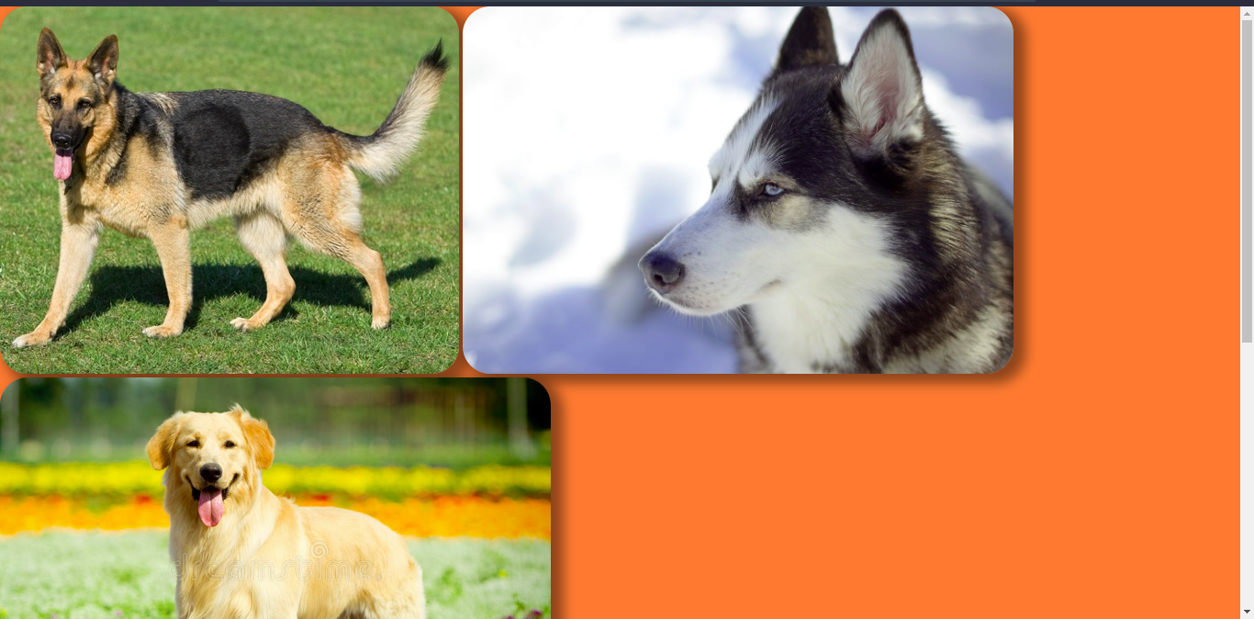

4.Design a chatbot using IBM Watson assistant for hospital.

Search for the watson assistant on cloud

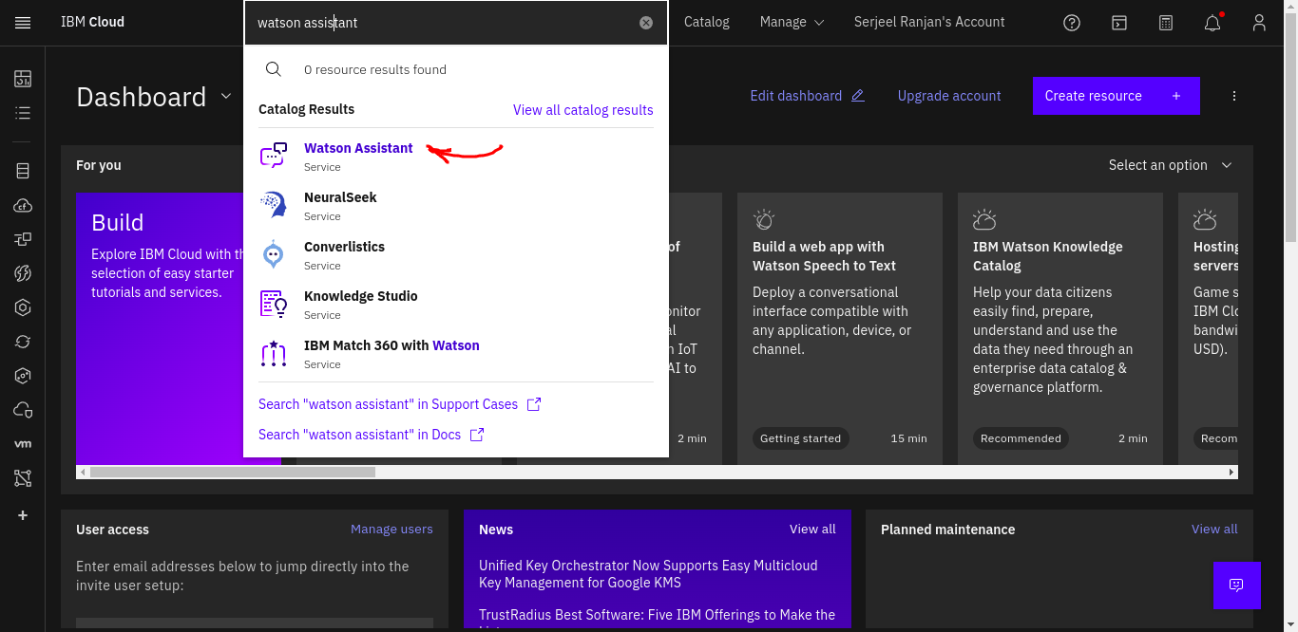

Give name to your service then click on create

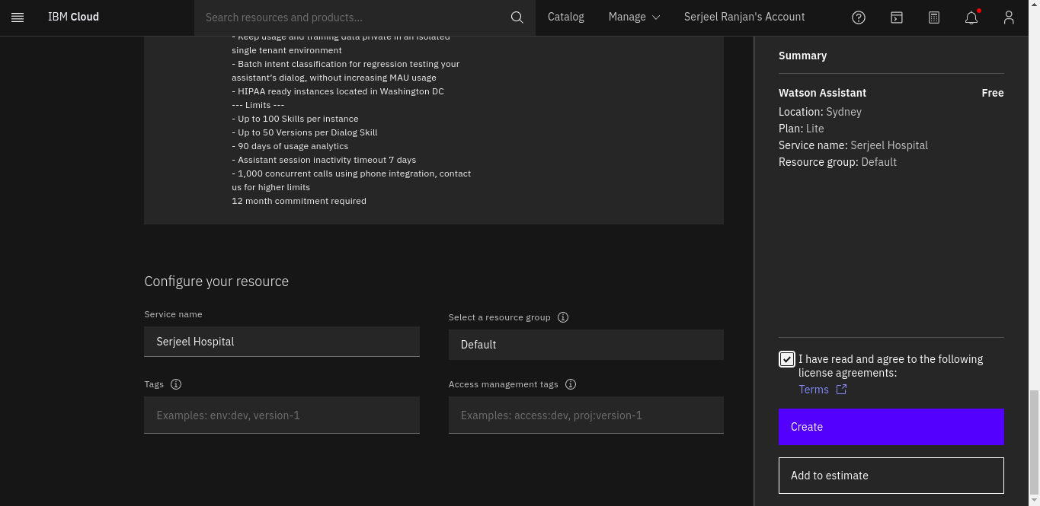

Click on launch

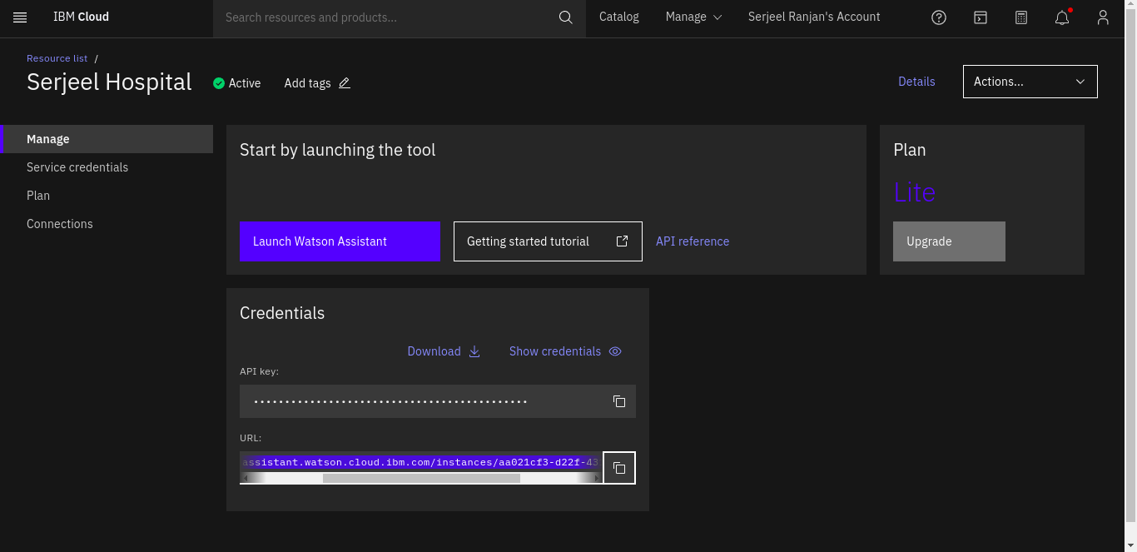

Give your assistant a name and description

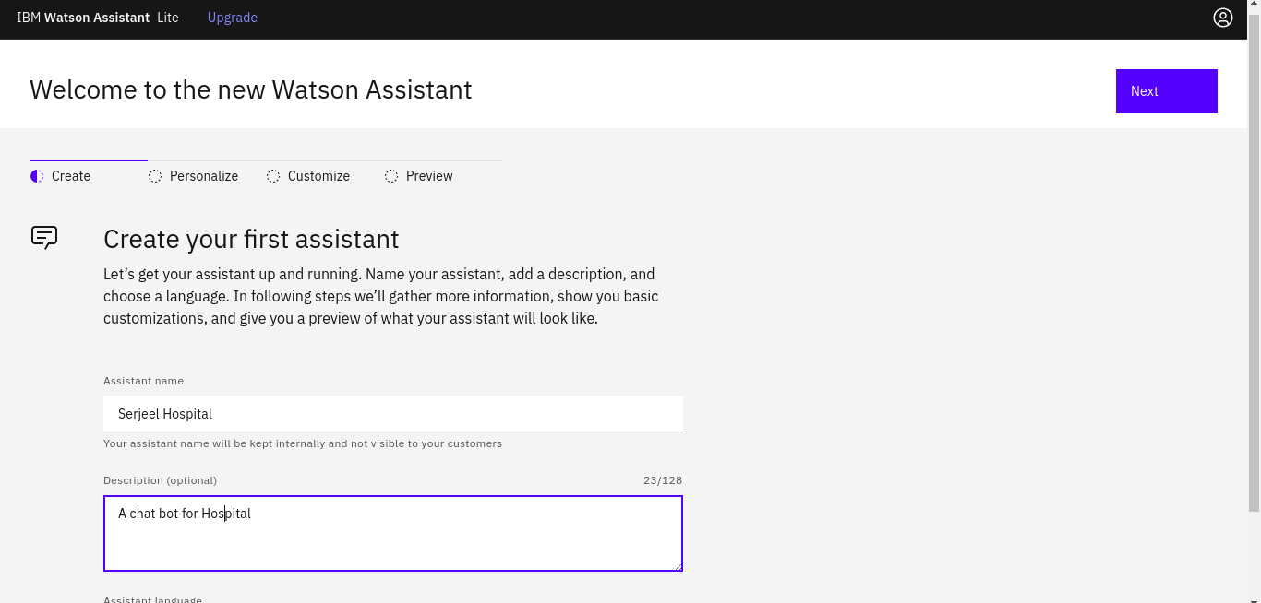

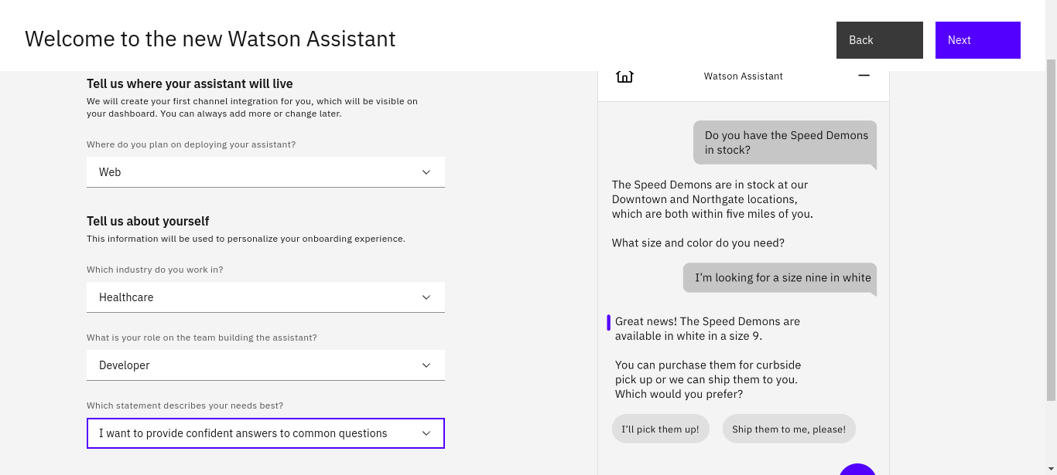

Personalizing the assistant

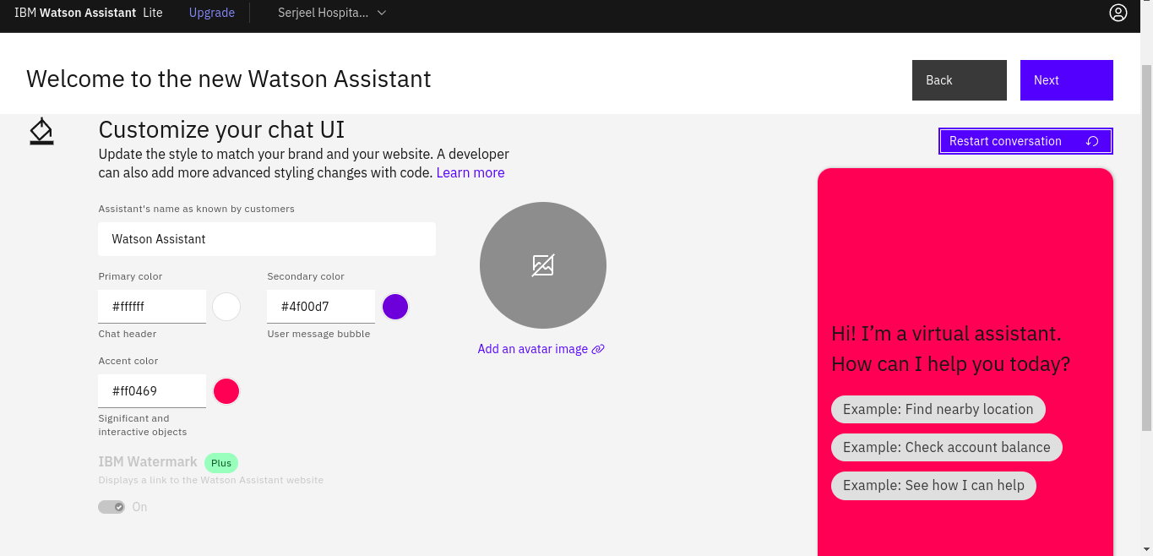

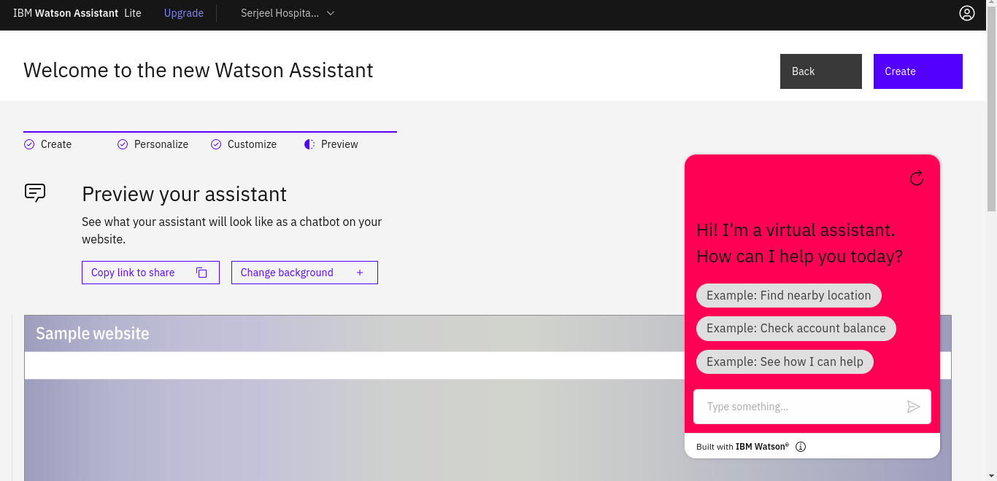

The CHAT BOT is live at - <https://web-chat.global.assistant.watson.appdomain.cloud/preview.html?backgroundImageURL=https%3A%2F%2Fau-syd.assistant.watson.cloud.ibm.com%2Fpublic%2Fimages%2Fupx-aa021cf3-d22f-4314-8218-6c9135c4f7f6%3A%3Aecf763fc-ae37-4661-a2d2-aadbc47fa0ed&integrationID=de8e8c66-b240-456e-a347-b2e68c4fe2bc&region=au-syd&serviceInstanceID=aa021cf3-d22f-4314-8218-6c9135c4f7f6>

5.Create Watson assistant service with 10 steps and use 3 conditions in it. Load that script in HTML page.

Create conversation for chat bot

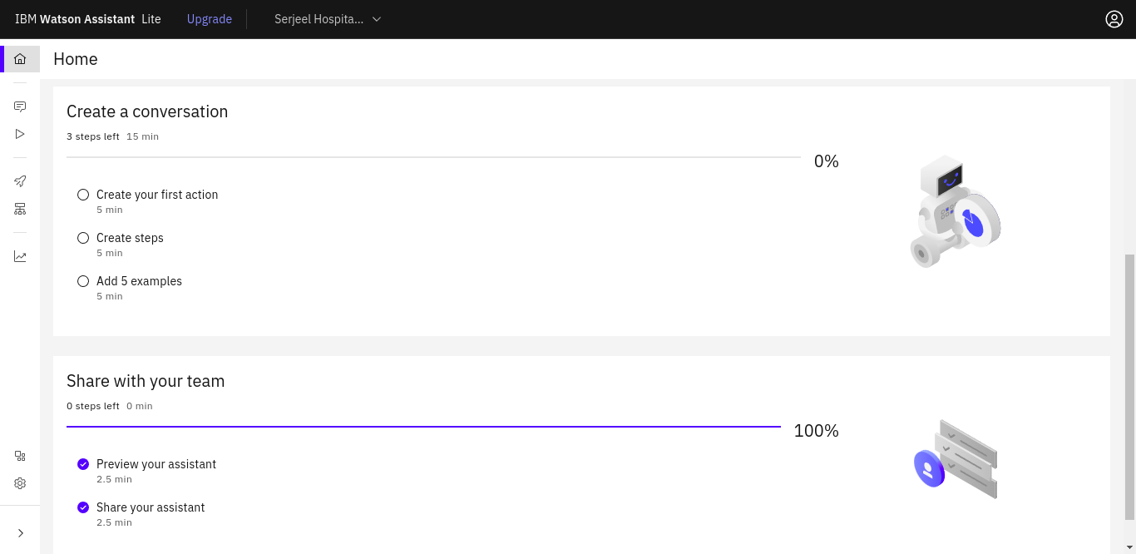

Set 10 steps

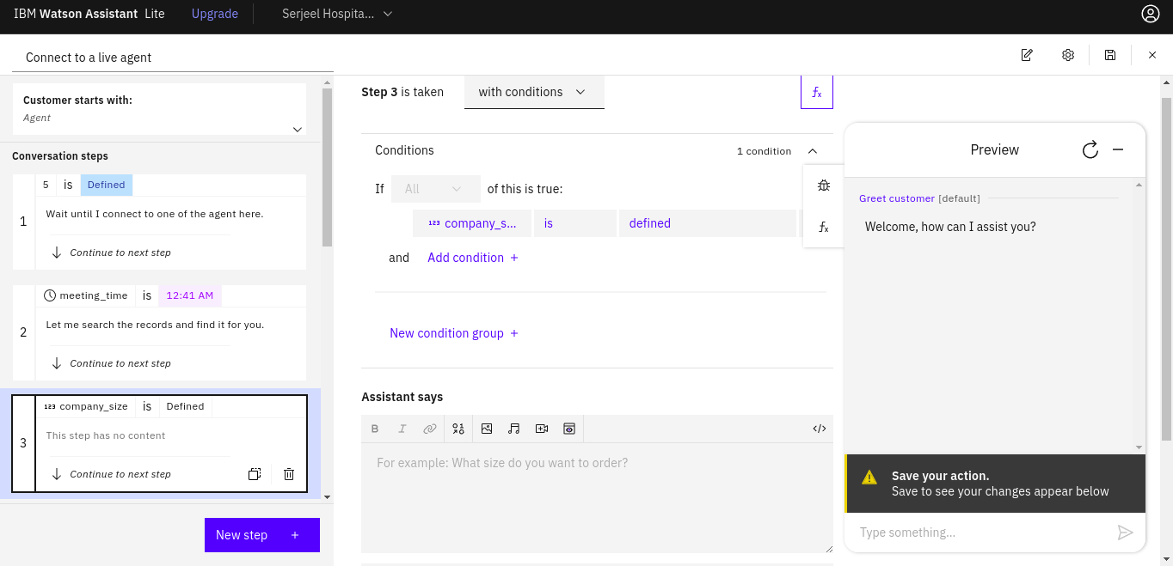

Adding conditions

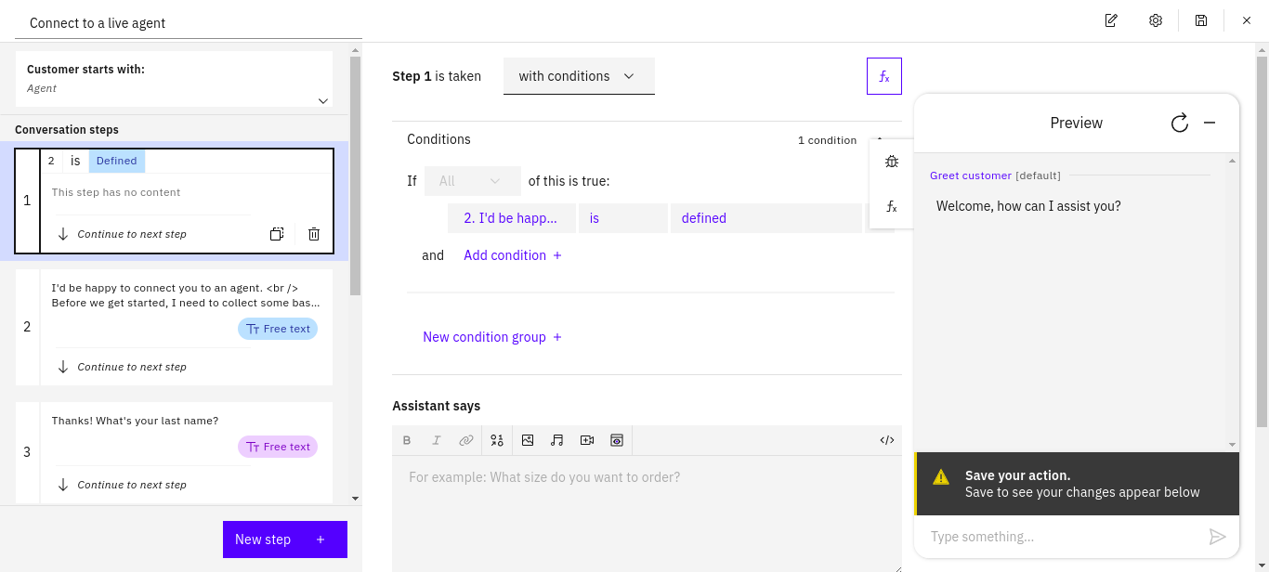

Embedding chatbot in html

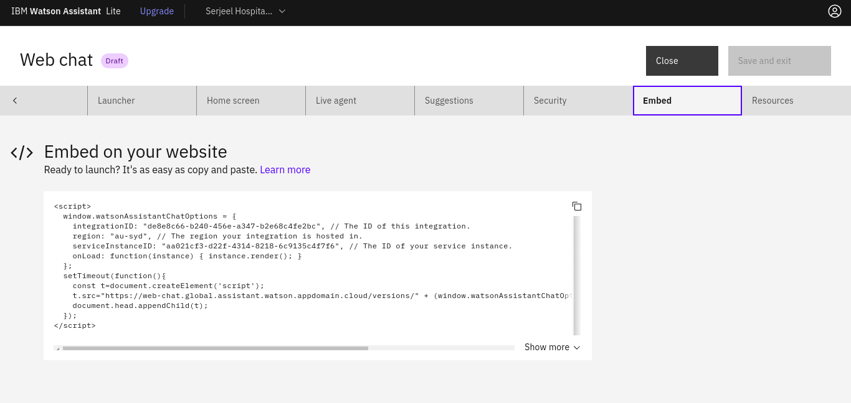

<!DOCTYPE html>

<html lang="en">

<head>

<title>IBM Assignment 3</title>

</head>

<body>

<script>

window.watsonAssistantChatOptions = {

integrationID: "de8e8c66-b240-456e-a347-b2e68c4fe2bc", // The ID of this integration.

region: "au-syd", // The region your integration is hosted in.

serviceInstanceID: "aa021cf3-d22f-4314-8218-6c9135c4f7f6", // The ID of your service instance.

onLoad: function (instance) {

instance.render();

},

};

setTimeout(function () {

const t = document.createElement("script");

t.src =

"https://web-chat.global.assistant.watson.appdomain.cloud/versions/" +

(window.watsonAssistantChatOptions.clientVersion || "latest") +

"/WatsonAssistantChatEntry.js";

document.head.appendChild(t);

});

</script>

</body>

</html>

OUTPUT

